MQM using the listeria dataset and testing the package

F2 intercross
No. individuals: 120
No. phenotypes: 2
Percent phenotyped: 96.7 100
No. chromosomes: 20
Autosomes: 1 2 3 4 5 6 7 8 9 10 11 12 13 14 15 16 17 18 19
X chr: X
Total markers: 133
No. markers: 13 6 6 4 13 13 6 6 7 5 6 6 12 4 8 4 4 4 4 2
Percent genotyped: 88.5

Using the prepareMQM function we created three input files for the MQM algorithm:

- Listeria_F2.QUA.txt (Phenotypes)
- Listeria_F2.MAR.txt (Genotypes)
- Mqm_in.txt (settings file for MQM)

Because not all individuals were not genotypes some of them were dropped by the algorithm when the dataaugmentation step because to large, for this we made 2 executables (MQM and MQMSloppy)

Using the readMQMout we plotted the resulting QTL’s, (red) the blue line is the information content at each marker.
Also we did the same for the package (no sloppy versions because of the huge amount of data augmentation), for the package the R commands are given below the plots.

RESULTS
Scanone Function from C. Brohman
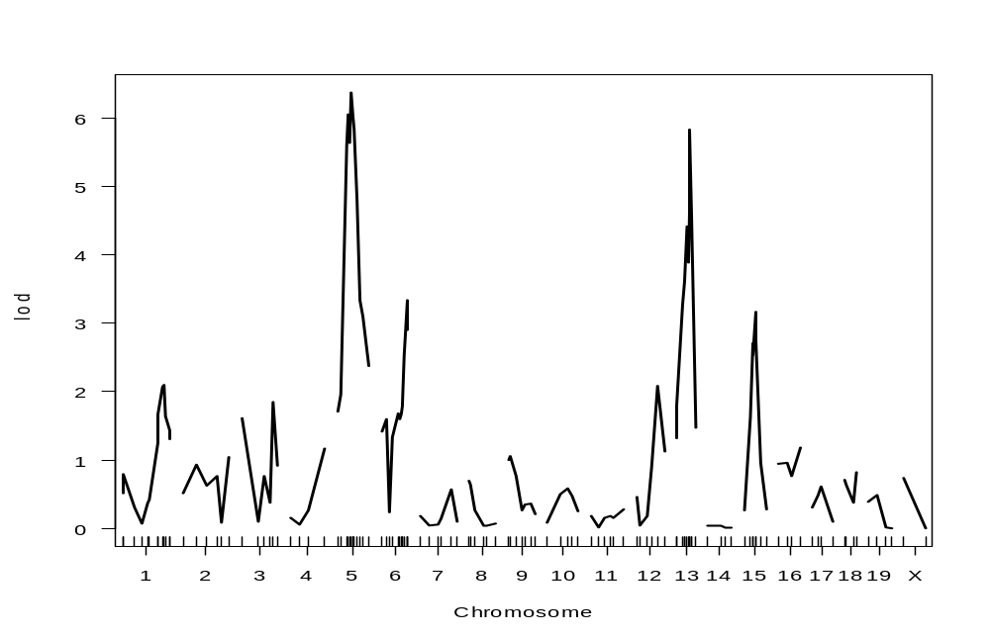
MQM Ritsert
First results of MQM – no cofactors selected
- 33 individuals thrown out as non-informative
- Neglect:1000 , MaxAug (1000 : 10.000)
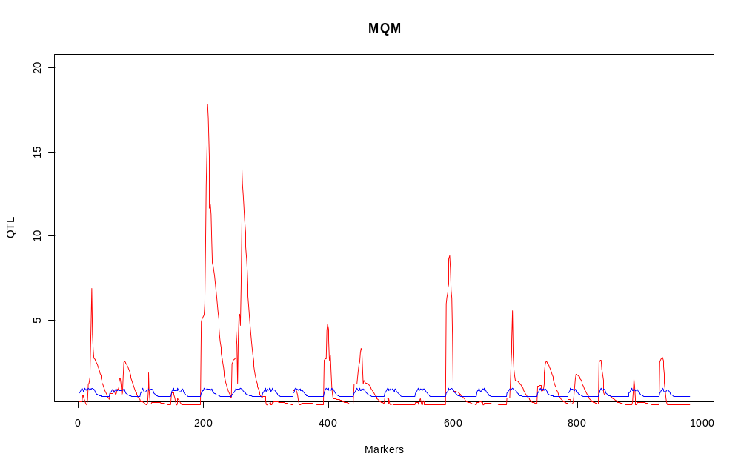
Second results – no cofactors selected
- 1 individual thrown out
- Neglect 10, MaxAug (10000 : 100.000)
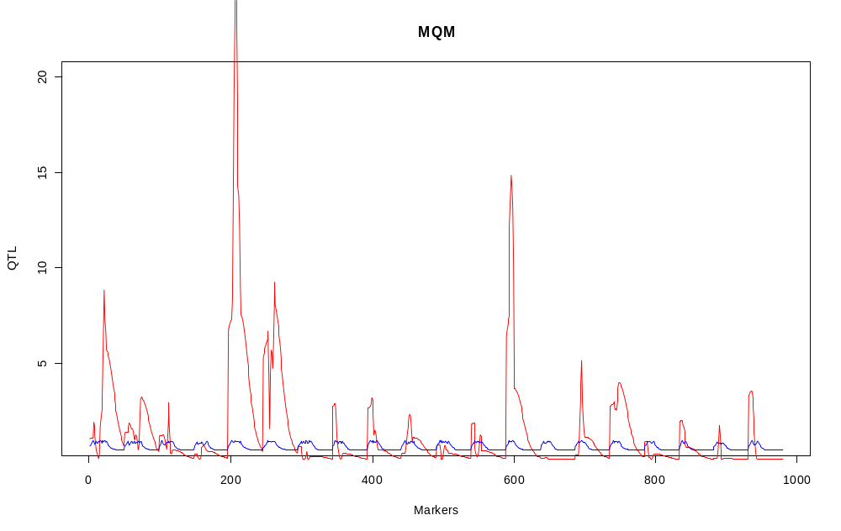
MQM with cofactors:
Using cofactors before running the algorithm
(2 for each chromosome (*) and 2 on the X chromosome (s)), when using:
- 33 individuals thrown out as non-informative
- Neglect:1000 , MaxAug (1000 : 10.000)
- Selection of 2 markers: 34 and 94 in the final model
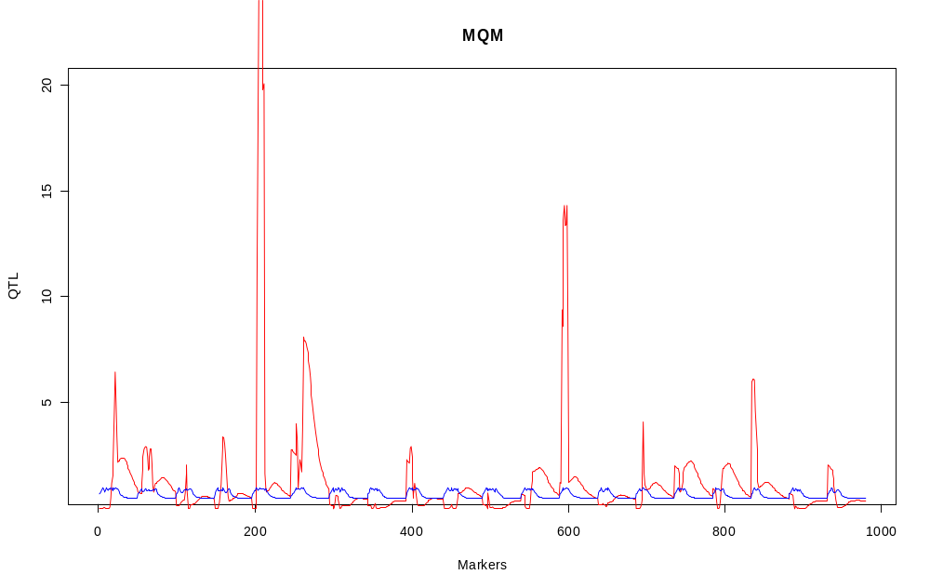
- Neglect 10, MaxAug (10000 : 100.000)
- Selection of 2 markers: 8 ,34 and 94 in the final model
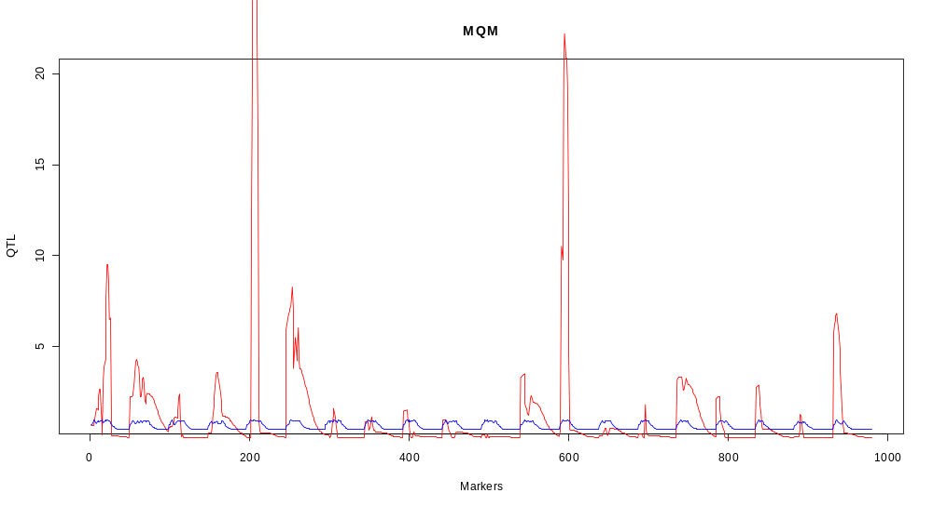

Using the package:
> Data(listeria)
> listeria_aug <- MQMaugment(listeria,maxaug=10000,maxiaug=1000,neglect=1000)
> result_aug <- scanMQM(listeria_aug)
> plot(result_aug)

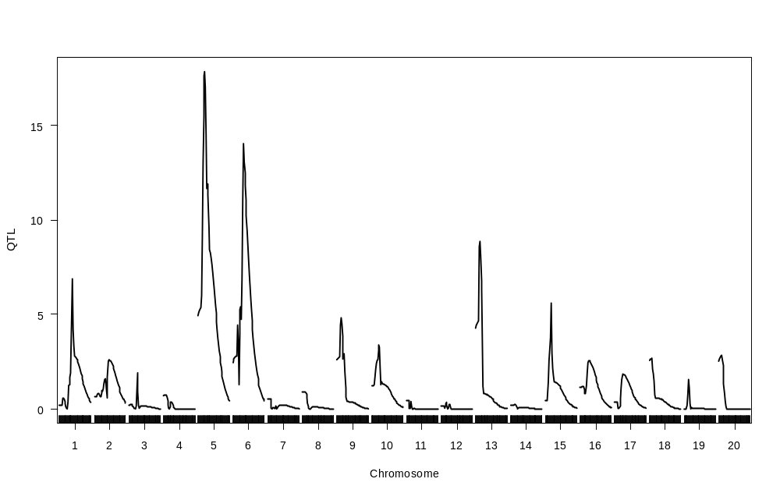
Cofactors
> Data(listeria)
> listeria_aug <- MQMaugment(listeria,maxaug=10000,maxiaug=1000,neglect=1000)
> a <- MQMCofactors(listeria_aug,c(5,10,15,20,30,35,40,50,60,70,80,90,95,100,105,110))
> result_aug_c <- scanMQM(listeria_aug,a)
> plot(result_aug_c)

MARKERS SELECTED: 34 & 99
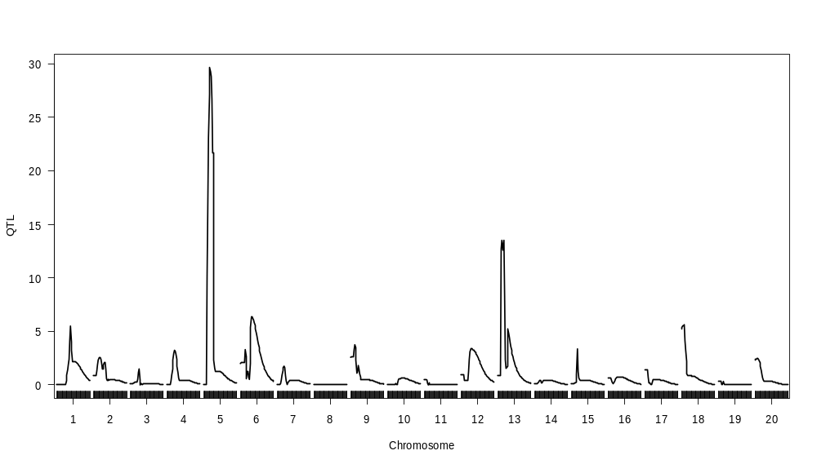

Closeup of chromosome 5,6,13
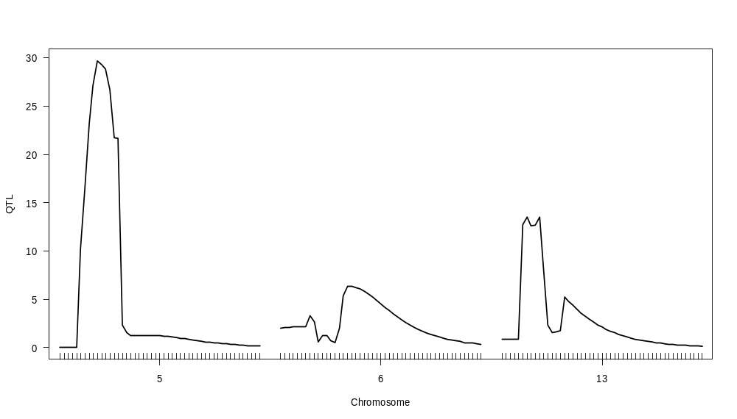
Not using the data augmentation form MQM
So replacing the incomplete genetic map using
> Data(listeria)
> Listeria_aug_rqtl <- fill.geno(listeria)
> result_aug_rqtl <- scanMQM(Listeria_aug_rqtl)
> plot(result_aug_rqtl)

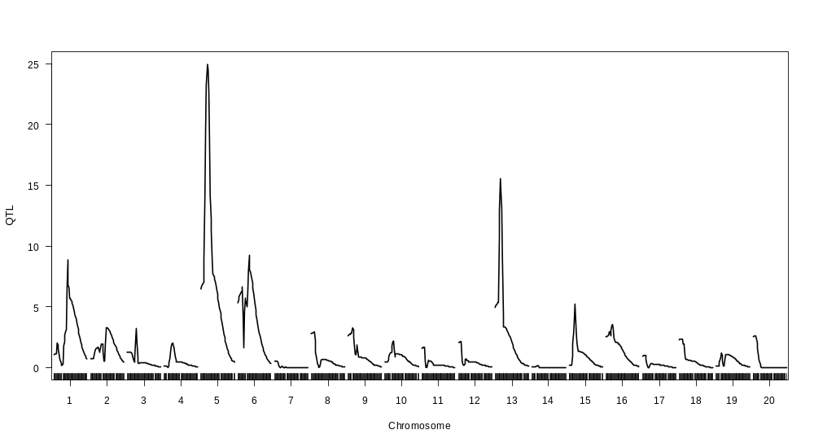
Using cofactors

> Data(listeria)
> L_aug_rqtl <- fill.geno(listeria)
> a <- MQMCofactors(L_aug_rqtl,c(5,10,15,20,30,35,40,50,60,70,80,90,95,100,105,110))
> L_aug_rqtl_c <- scanMQM(L_aug_rqtl,a)
> plot(L_aug_rqtl_c)

Markers selected: 9, 34, 94

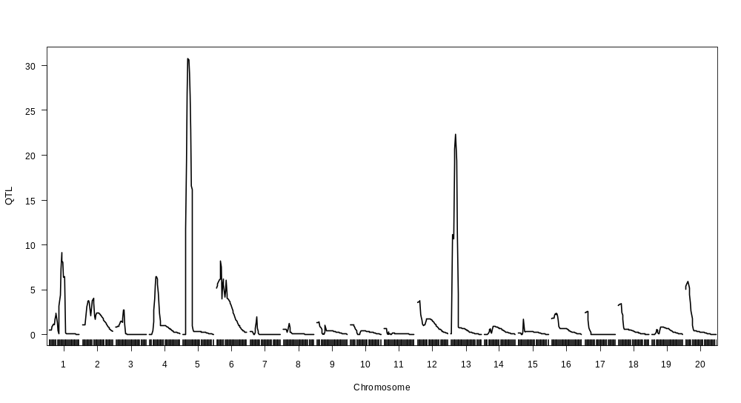
List of individuals dropped when using strict MQM dataaugmentation:
individual 42 is eliminated, because it is not informative enough
individual 45 is eliminated, because it is not informative enough
individual 90 is eliminated, because it is not informative enough
individual 91 is eliminated, because it is not informative enough
individual 92 is eliminated, because it is not informative enough
individual 93 is eliminated, because it is not informative enough
individual 94 is eliminated, because it is not informative enough
individual 95 is eliminated, because it is not informative enough
individual 96 is eliminated, because it is not informative enough
individual 97 is eliminated, because it is not informative enough
individual 98 is eliminated, because it is not informative enough
individual 99 is eliminated, because it is not informative enough
individual 100 is eliminated, because it is not informative enough
individual 101 is eliminated, because it is not informative enough
individual 102 is eliminated, because it is not informative enough
individual 103 is eliminated, because it is not informative enough
individual 104 is eliminated, because it is not informative enough
individual 105 is eliminated, because it is not informative enough
individual 106 is eliminated, because it is not informative enough
individual 107 is eliminated, because it is not informative enough
individual 108 is eliminated, because it is not informative enough
individual 109 is eliminated, because it is not informative enough
individual 110 is eliminated, because it is not informative enough
individual 111 is eliminated, because it is not informative enough
individual 112 is eliminated, because it is not informative enough
individual 113 is eliminated, because it is not informative enough
individual 114 is eliminated, because it is not informative enough
individual 115 is eliminated, because it is not informative enough
individual 116 is eliminated, because it is not informative enough
individual 117 is eliminated, because it is not informative enough
individual 118 is eliminated, because it is not informative enough
individual 119 is eliminated, because it is not informative enough

